Note: Use high good resolution image along with each question.

Front size and size must clear to all age group audience.

Art object: Darshan Dwar Phulkari

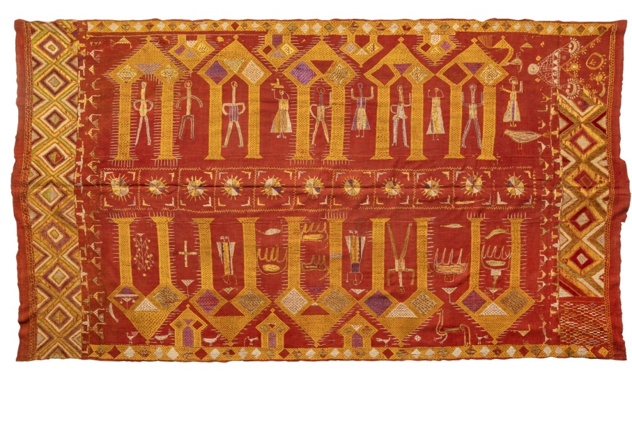

Question1: What is the name of this traditional embroidered textile from Punjab?

Kalamkari  
**B)** Phulkari  
**C)** Madhubani  
**D)** Warli

**Correct Answer:** **B) Phulkari**

Question2: **What is the main embroidery technique used in Phulkari?**  
A) Block Printing  
B) Weaving  
C) Thread Embroidery  
D) Appliqué Work

**Correct Answer:** **C) Thread Embroidery**

**Depiction of Ramayana**

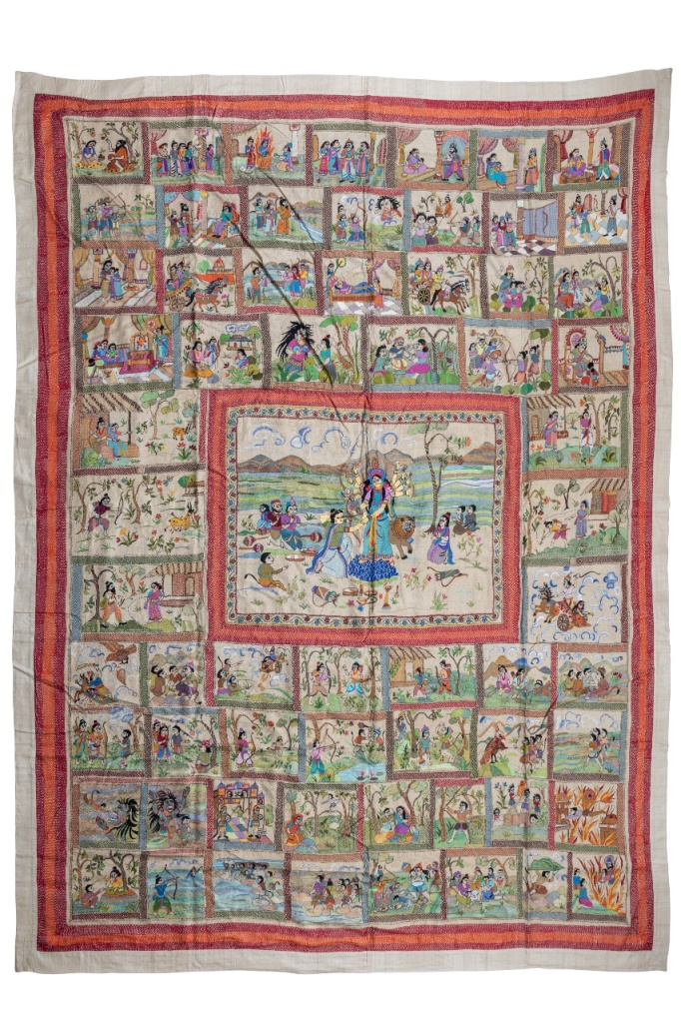

**Question 3: Which Indian epic is shown in this Kantha embroidery?**

A) Ramayana

B) Mahabharata  
C) Jataka Tales  
D) Panchatantra

**Correct Answer:** **A) Ramayana**

Question 4: **Which main character is performing Durga Puja in the center of this Kantha embroidery?**

A) Hanuman  
 B) Ravana  
 C) Rama  
 D) Lakshmana

**Correct Answer:** **C) Rama**

**Question 5: Can you count how many different scenes are depicted in this beautiful artwork? Look carefully at the large central scene and all the smaller ones around it!"**

**Options:**  
A) 30  
B) 45  
C) 55  
D) 60

**Correct Answer: D)60 RECHECK**

Navagunjara Patachitra

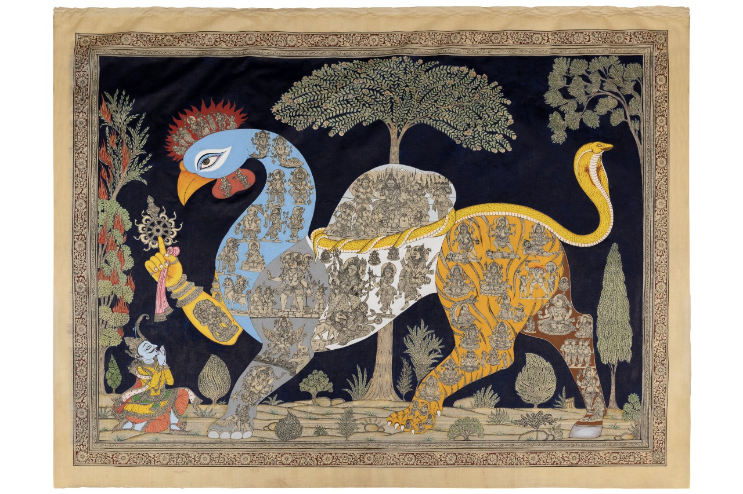

Question 6: Which of the following animals is NOT a part of the Navagunjara?

A) Peacock  
 B) Elephant  
 C) Lion  
D) Snake

The correct answer C) Lion

Question 7: The Navagunjara art form belongs to which Indian state?

A) Rajasthan  
B) Odisha  
C) Tamil Nadu  
D) West Bengal

**Correct Answer:** B) Odisha

Question 8:What is Navagunjara holding in its hand?

A) A bow and arrow  
B) A lotus flower  
C) A chakra   
D) A conch shell

**Correct Answer:** C) A chakra Recheck

Question 9: Navagunjara is a unique mythical creature made up of different animal parts. Can you match the correct animal parts to their respective positions from **left to right** in the figure?

**Head** , **Neck & Body**, **Hump**, **Front Left Leg** , **Front Right Leg (Holding Chakra)** ,**Back Left Leg** ,**Back Right Leg**.

**Options:**  
A) Peacock, Snake, Bull, Elephant, Human Hand, Deer, Tiger  
B) Elephant, Peacock, Bull, Snake, Tiger, Deer, Human Hand  
C) Bull, Snake, Peacock, Elephant, Human Hand, Tiger, Deer  
D) Tiger, Human Hand, Peacock, Snake, Bull, Deer, Elephant

**Correct Answer:**  
**A) Peacock, Snake, Bull, Elephant, Human Hand, Deer, Tiger** (Left to Right Order)

**Activity Idea:** Arrange all pieces of the art

**Fun Activity: "Assemble the Navagunjara!"**

Visitors will receive **separate puzzle pieces** of Navagunjara’s different animal parts. Their challenge is to correctly **assemble the mythical creature** by placing each piece in its proper position.

Hanuman Dancing Mask

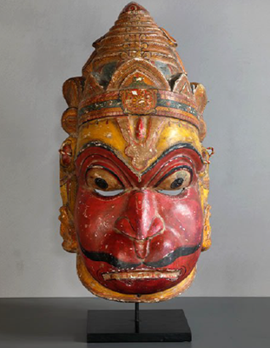

Question 10: What is the **Sahi Jata** festival of Puri known for?

A) Playing musical instruments  
B) Telling stories through dance  
C) Cooking traditional food  
D) Flying kites

**Correct Answer:** **B) Telling stories through dance**

Question 11: What is the main color traditionally used in Sahi Jata face masks?

**Options:**  
A) Blue  
B) Red  
C) Yellow  
D) Green

**Correct Answer:** B) Re

Mumbai Lifestyle

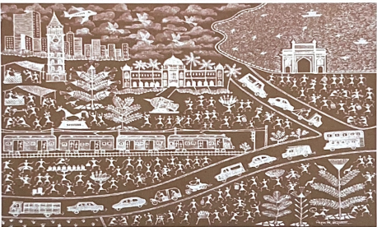

Question 12: How many autos and cars can you count in the 'Mumbai Lifestyle'- Warli painting? Look closely and find them all

A) 3 &5  
B) 1& 7  
C) 2& 10  
D) 1& 10

**Correct Answer: B) 1&7 RECHECK**

Question 13: In the "Mumbai Lifestyle" Warli painting by artist Kiran Vinayak Gorwala, which modes of transportation are depicted?

A) Road, rail and sea.  
B) Road & rail  
C) Road, rail, sea, air  
D) Road

Correct Answer: C) Road, rail, sea, air

Jumadi Bhuta Mask

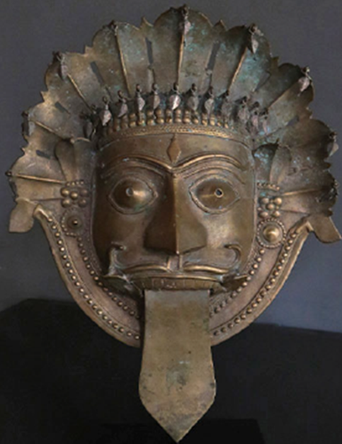

Question 14: This is a traditional mask used in rituals and performances. Can you guess which spirit deity it represents?

**A) Hanuman  
B) Jumadi Bhuta   
C) Ganesha  
D) Kali**

**Correct Answer: Jumadi Bhuta**

Question 15: Can you count the number of cobra (snake) faces shown on the headgear of the Jumadi Bhuta mask?"

**A) 9  
B) 8  
C) 7  
D) None**

**Correct Answer: 9 Recheck**

Question 16: Where Jumadi Bhuta masks mainly belong to?

**A) Rajasthan & Gujarat**  
**B) Karnataka & Kerala**  
**C) Tamil Nadu & Andhra Pradesh**  
**D) West Bengal & Odisha**

**Correct Answer:** Karnataka & Kerala

Question 17: What is a distinctive feature often found on Jumadi Bhuta masks?

**A) Cobra hoods  
B) Peacock feathers  
C) Tiger stripes  
D) Elephant tusks**

**Correct Answer: Cobra hoods**

Question 18: Which material is traditionally used to make bhuta masks?

**A) Wood  
B) Paper   
C) Metal  
D) bone**

**Correct Answer: Metal**

**Tree of Life**

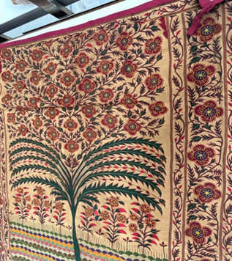

**Question 19: "The Tree of Life" – art work from Ahmedabad (Gujarat) is an important symbol in many tribal and folk art forms. What does it usually represent?**

**A) A place for birds to sit**  
**B) The connection between nature and life**  
**C) A giant umbrella**  
**D) A magic tree that grants wishes**

**Correct Answer: B) The connection between nature and life.**

Question 20: Look closely at the "Tree of Life" artwork. How many pairs of green colour branches can you count in the tree?

**A) 4 pairs**  
**B) 6 pairs**  
**C) 5 pairs**  
**D) 10 pairs**

**Correct Answer: C) 5 pairs.**

